StreamFlix Content Analytics
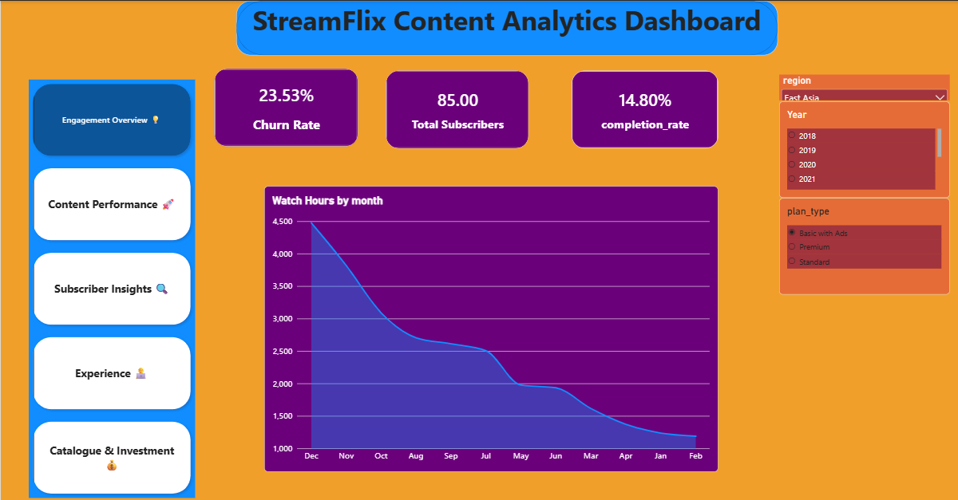
- Executive Summary
- Developed a Power BI Business Intelligence dashboard to analyze 6 StreamFlix datasets comprising approximately 979,000 records.
- Applied PostgreSQL and Python for data preparation, cleaning, quality checks, EDA, and analytical processing before dashboard development.
- Analyzed major business areas including subscriber engagement, viewing behavior, churn, retention, content performance, ratings, reviews, and watchlists.
- Derived essential KPIs and business metrics such as watch hours, completion rate, active rate, MRR, ARPU, and watchlist conversion.
- Created interactive dashboard views to monitor engagement, content performance, subscriber insights, user experience, and catalogue trends.
- The final solution delivers actionable business insights through interactive reporting, enabling data-driven decision-making and performance monitoring.
- Problem Solved
StreamFlix’s data is distributed across 6 interconnected datasets containing approximately 979,000 records, making it difficult to quickly identify meaningful patterns in subscriber behavior, content performance, and platform engagement. This project organizes, cleans, analyzes, and visualizes the data through PostgreSQL, Python, and an interactive Power BI dashboard. It enables users to examine viewing trends, subscriber engagement, churn, retention, content performance, ratings, reviews, and watchlist activity. Key KPIs and business metrics bring important platform performance indicators into a single analytical view. The solution reduces the need for manual and disconnected analysis, making complex streaming data easier to explore and supporting data-driven decision-making.
- Key Insights
- Drama and Comedy show the highest completion rates, indicating strong viewer engagement with these genres, while Musical and Family content have comparatively lower completion rates.
- TV Shows account for 86.5% of total watch hours, compared with 13.5% for Movies, indicating that viewer consumption is heavily concentrated on TV Shows content.
- The data reveals a clear geographic concentration in watch activity, led by the United States, while the United Kingdom, South Korea, and Japan form the next strongest markets.
- Cohort analysis shows generally strong subscriber retention, with most cohorts maintaining high retention through 3 and 6 months and only modest declines by 12 months, suggesting strong long-term customer stickiness.
- Smart TVs lead device usage, followed by mobile devices, highlighting a strong preference for large-screen and on-the-go viewing.

- Business Recommendations
- Prioritize investment in high-engagement genres: Increase content acquisition and production investment in Drama and Comedy, given their stronger completion rates. Use these genres as core engagement drivers while reviewing lower-performing Musical and Family content to identify opportunities for improvement.
- Strengthen the TV Show content strategy: Since TV Shows generate 86.5% of total watch hours, prioritize high-quality series, renewals, and exclusive episodic content. Use Movies as a complementary offering rather than the primary driver of viewing time.
- Focus market strategy on high-consumption regions: Prioritize localized content, marketing campaigns, and partnerships in the United States, United Kingdom, South Korea, and Japan. At the same time, assess underpenetrated markets for targeted growth opportunities.
- Protect long-term subscriber retention: With cohorts demonstrating strong retention through 3 and 6 months and relatively modest declines by 12 months, focus on maintaining this performance through personalized recommendations, consistent content releases, and proactive re-engagement campaigns for subscribers showing declining activity.
- Optimize the viewing experience across key devices: Prioritize the Smart TV experience because it represents the leading viewing device, while continuing to improve mobile usability for on-the-go consumption. Ensure seamless cross-device playback, synchronization, and personalized recommendations to support a consistent subscriber experience.
- Risks Identified
- Churn Rate — 25.34%: The clearest concern. Roughly 1 in 4 subscribers is inactive/churned, which can weaken recurring revenue and increase pressure on customer acquisition.
- Watchlist Conversion — 46.23%: Less than half of watchlisted titles are actually watched, suggesting a gap between content interest and actual consumption.
- Originals Share of Watch Hours — 27.17%: Originals generate only about a quarter of total viewing hours. If original productions require significant investment, their engagement return should be reviewed against production/content costs.
- Average Completion Rate — 65.31%: Viewers leave roughly 34.69% of content unwatched on average, indicating potential engagement or content-fit issues.
- Active Subscriber Rate — 74.66%: While the majority remain active, the remaining 25.34% inactive share represents a meaningful retention risk.
- Opportunities
- Scale high-engagement content: Expand investment in Drama and Comedy, where completion rates are strongest, and use viewer-level engagement data to identify similar themes, formats, and titles that can generate additional watch time.
- Deepen TV Show engagement: With TV Shows contributing 86.5% of total watch hours, strengthen the episodic content pipeline through new series, timely renewals, and personalized next-episode or related-series recommendations to encourage repeat viewing.
- Convert watchlist intent into viewing: Improve the 46.23% watchlist conversion rate through personalized reminders, “Continue from Your Watchlist” recommendations, and better content discovery, turning existing viewer interest into incremental watch hours.
- Strengthen retention through personalization: Build on the strong 3-, 6-, and 12-month cohort retention by continuously recommending relevant content based on viewing history, genre preferences, watchlists, and completion behavior, while optimizing discovery across Smart TV and mobile experiences.
- Reduce churn through early intervention: Address the 25.34% churn/inactive rate by identifying subscribers with declining viewing activity and targeting them with personalized recommendations, new-release alerts, and re-engagement campaigns before they disengage completely.
- Tools & Techniques
- PostgreSQL — Basic Cleaning & Analysis
- Python — Data Cleaning & Quality Analysis & EDA & KPI’s
- Power BI — Dashboard

